Version 1.0

syst 17796

Deliverable 3

**Table OF Contents**

Syst 17796 Deliverable 3 1

Unified Modeling Language Diagram 2

Gir repository URLs 2

Test result report 3

## UML Diagram

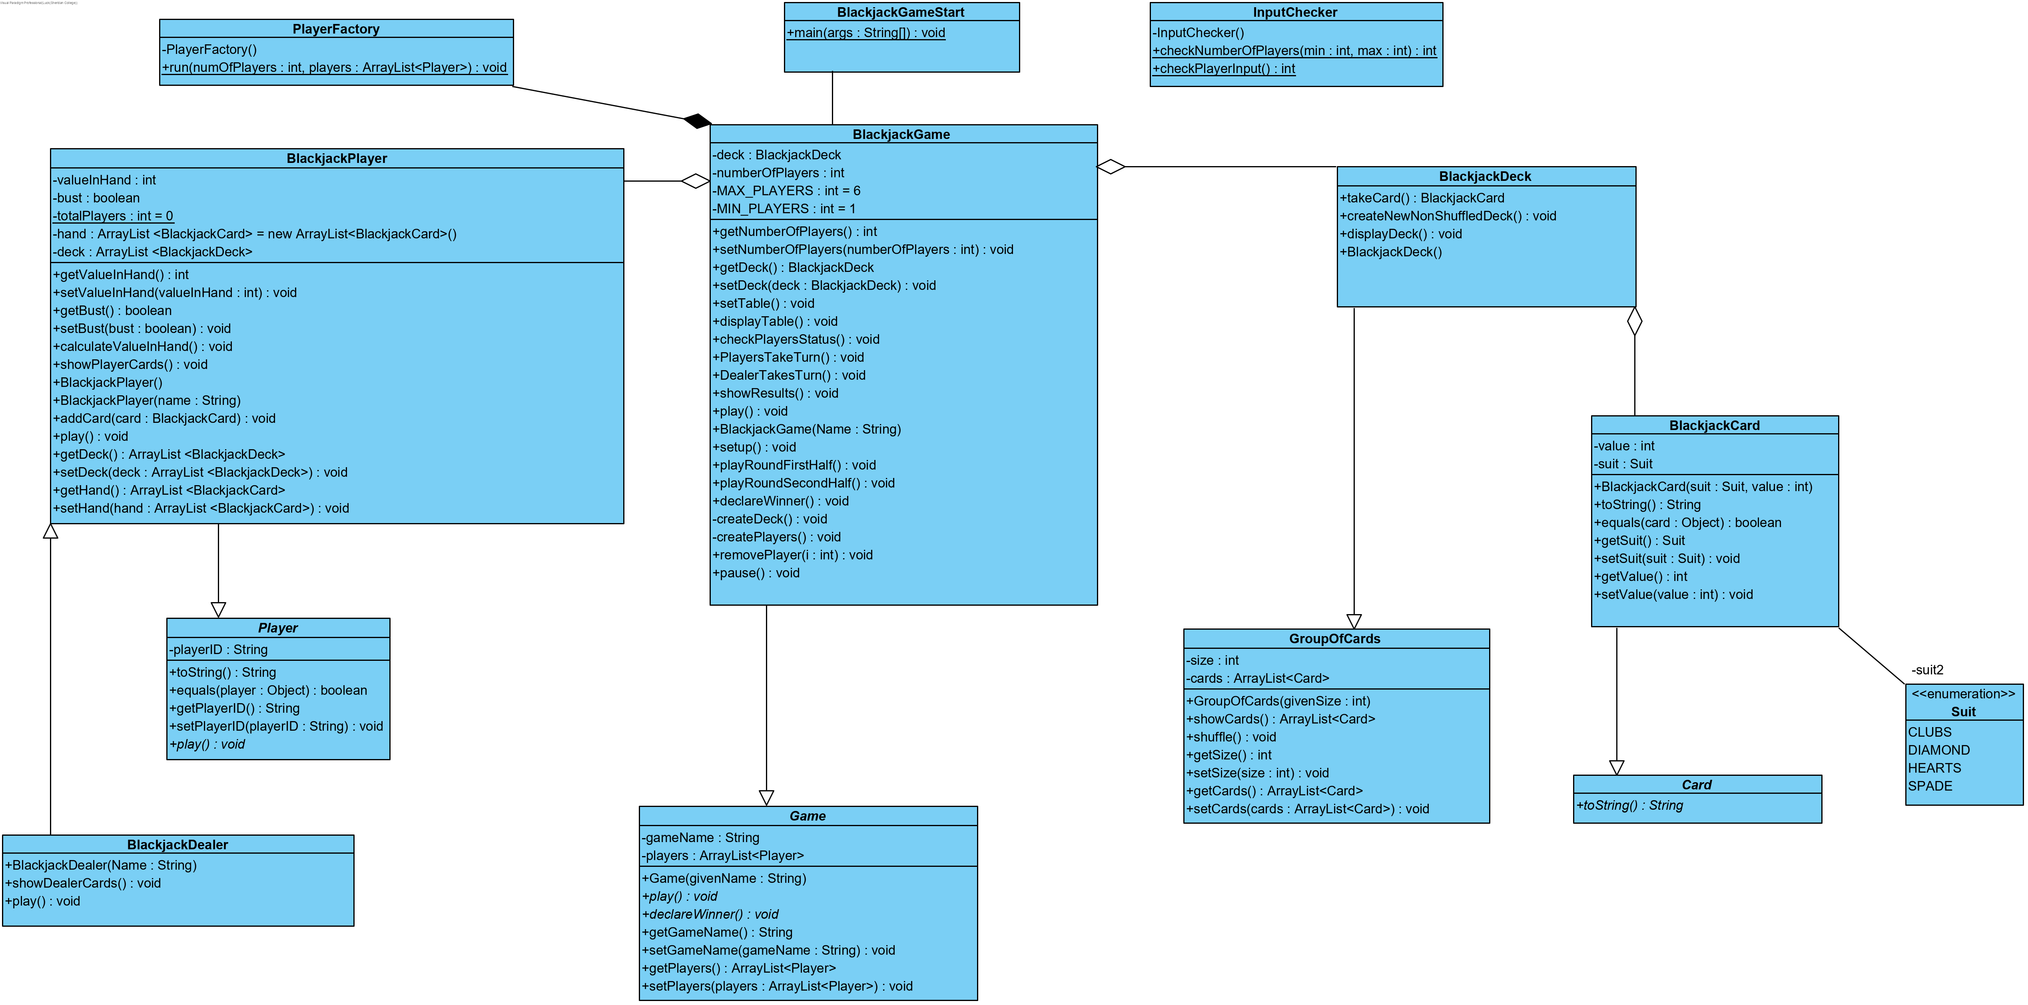

## Git repository

Source URL : <https://github.com/Danny-Chaudhry/Deliverable_1/tree/master/src/ca/sheridancollege/project>

Testing URL : <https://github.com/Danny-Chaudhry/Deliverable_1/tree/master/test/ca/sheridancollege/project>

## Test Result report

|  |  |  |  |
| --- | --- | --- | --- |
| Requirement | Use Case | Test Method (ClassName.methodName) | Status (Date) |
| Card instance can be created | “Main path” | Test class: TestBlackjackCardClass  Method: BlackjackCard() | Pass (April 19, 2019) |
| Cards equal method | “Main path” | Test class: TestBlackjackCardClass  Method: equals() | Pass (April 19, 2019) |
| Player instance without name | “Main path” | Test class: TestBlackjackPlayerClass  Method: BlackjackPlayer() | Pass (April 19, 2019) |
| Player instance with name | “Main path” | Test class: TestBlackjackPlayerClass  Method: BlackjackPlayer(“Name”) | Pass (April 19, 2019) |
| Calculate value in player hand | “Main path” | Test class: TestBlackjackPlayerClass  Method: calculateValueInHand() | Pass (April 19, 2019) |
| Show players hand | “Main path” | Test class: TestBlackjackPlayerClass  Method: showPlayerCards() | Pass (April 19, 2019) |
| Player automatically takes card if less than 16 | “First alternative” | Test class: TestBlackjackPlayerClass  Method: play () | Pass (April 19, 2019) |
| Player ‘hit me’ | “Third alternative” | Test class: TestBlackjackPlayerClass  Method: play() | Pass (April 19, 2019) |
| Player ‘stay’ | “Third alternative” | Test class: TestBlackjackPlayerClass  Method: play() | Pass (April 19, 2019) |
| Player ‘go bust’ | “Forth alternative” | Test class: TestBlackjackPlayerClass  Method: play() | Pass (April 19, 2019) |
| Player ‘gets 21’ | “Main path” | Test class: TestBlackjackPlayerClass  Method: play() | Pass (April 19, 2019) |
| Dealer instance can be created | “Main path” | Test class: TestBlackjackDealerClass  Method: BlackJackDealer(”DEALER”) | Pass (April 19, 2019) |
| Showing the dealer’s cards | “Third alternative” | Test class: TestBlackjackDealerClass  Method: showDealerCards() | Pass (April 19, 2019) |
| Dealer automatically takes card if less than 16 | “Third alternative” | Test class: TestBlackjackDealerClass  Method: play() | Pass (April 19, 2019) |
| Deck instance can be created | “Main path” | Test class: TestBlackjackDeckClass  Method: BlackjackDeck() | Pass (April 19, 2019) |
| Display the deck | “Main path” | Test class: TestBlackjackDeckClass  Method: displayDeck() | Pass (April 19, 2019) |
| Shuffle deck | “Main path” | Test class: TestBlackjackDeckClass  Method: shuffle() | Pass (April 19, 2019) |
| Take card from deck | “Main path” | Test class: TestBlackjackDeckClass  Method: takeCard() | Pass (April 19, 2019) |
| Game instance can be created | “Main path” | Test class: TestBlackjackGameClass  Method: Blackjackgame() | Pass (April 19, 2019) |
| Create deck and shuffle it | “Main path” | Test class: TestBlackjackGameClass  Method: ceateDeck() | Pass (April 19, 2019) |
| Create a number of players | “Main path” | Test class: TestBlackjackGameClass  Method: createPlayers () | Pass (April 19, 2019) |
| Give each player two cards | “Main path” | Test class: TestBlackjackGameClass  Method: setTable () | Pass (April 19, 2019) |
| Display everyone’s cards | “Main path” | Test class: TestBlackjackGameClass  Method: displayTable () | Pass (April 19, 2019) |
| Remove player | “Second path” | Test class: TestBlackjackGameClass  Method: removePlayer() | Pass (April 19, 2019) |
| Display details for all remaining players | “Second path” | Test class: TestBlackjackGameClass  Method: displayPlayerStatus() | Pass (April 19, 2019) |
| Give each players their turn to play | “Main path” | Test class: TestBlackjackGameClass  Method: playersTakeTurn() | Pass (April 19, 2019) |
| Make the dealer play | “Main path” | Test class: TestBlackjackGameClass  Method: dealerTakesTurn() | Pass (April 19, 2019) |
| Show when player goes bust | “Second path” | Test class: TestBlackjackGameClass  Method: showResults() | Pass (April 19, 2019) |
| Show when player gets exactly 21 | “First path” | Test class: TestBlackjackGameClass  Method: showResults() | Pass (April 19, 2019) |
| Show when player still in game | “Third path” | Test class: TestBlackjackGameClass  Method: showResults() | Pass (April 19, 2019) |
| Dealer wins when getting 21 | “Forth path” | Test class: TestBlackjackGameClass  Method: declareWinner() | Pass (April 19, 2019) |
| Dealer loses when going bust | “Third path” | Test class: TestBlackjackGameClass  Method: declareWinner() | Pass (April 19, 2019) |
| Player wins when value greater than dealer | “Third path” | Test class: TestBlackjackGameClass  Method: declareWinner() | Pass (April 19, 2019) |
| Dealer wins when value greater than player | “Third path” | Test class: TestBlackjackGameClass  Method: declareWinner() | Pass (April 19, 2019) |
| Draw when both player and dealer have same value | “Third path” | Test class: TestBlackjackGameClass  Method: declareWinner() | Pass (April 19, 2019) |